**To Install Printer to Laptop**

**Macs** <https://global.sharp/restricted/products/copier/downloads/select_os_us.html?pid=448&region=10&lang=2>

PLEASE NOTE: on most Macs you can simply add printer rather than downloading a driver.

If this doesn't work, laptops can be connected to the printer with an IP address by following these steps:

1. Go to **Printers & Scanners**, then select **IP** in the top menu
2. Manually enter the printer’s **IP address** (which can be found on a **sticker on the printer**)
3. Then select **Add** at the bottom and print a test page.

**Windows**

[Driver Downloads - Find drivers - | Sharp Digital MFPs / Printers (global.sharp)](https://global.sharp/restricted/products/copier/downloads/search/us/detail/011811/download.html#download)

Select Country/Region: ***Oceania*** > Enter Product Name: ***BP-70C45*** > Product Category: ***Drivers for Colour Models*** > Filter by Product Name: ***BP series*** >Product Name: ***BP-70C45*** > Language: ***US English***

Select ***Next***

Select ***Next*** again

Select ***PCL6 / PS / PPD Drivers [WHQL]***

Scroll to bottom of page and select ***Download***

Click on ***Next***

Click on ***Add New Printer (if this appears, if not skip to next)***

Click on ***Standard Installation***

Tick the Box on with the ***Sharp BP70C45***

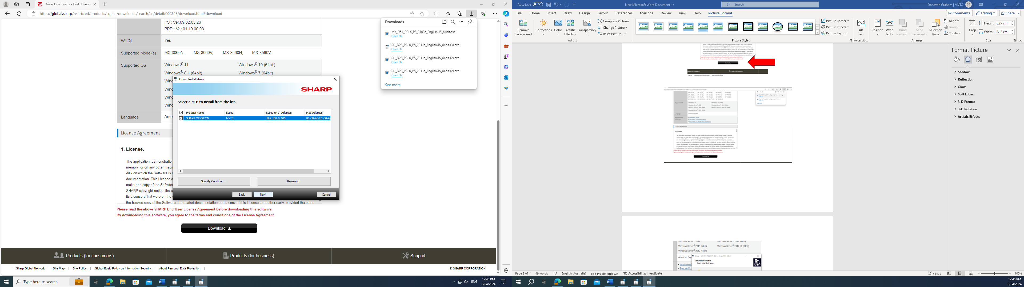

Click on ***Next***

Click on ***Finish***

